ECE 445

Senior Design Laboratory

Project Proposal

**Automatic Humidity Sensing and Water Refilling Cool-Mist Humidifier**

**Team No. 11**

Andrew Sherwin

(zyxie2@illinois.edu) Jalen Chen

(jalenc3@illinois.edu) Woojin Kim

(wkim51@illinois.edu)

***TA***: Surya Vasanth

***Professor***: Dr. Jonathon Schuh

February 08, 2024

Table of Contents

Abstract 3

Introduction 4

Problem 4

Solution 4

Visual Aid 5

High Level Requirements 5

Design 6

Block Diagram 6

Subsystem Overview / Requirements 6

Humidifier Subsystem: 6

Humidity Sensor Subsystem: 7

Subsystem Requirements 7

Tolerance Analysis / Potential Error 8

Ethics and Safety 11

References 13

## Abstract

Improper indoor humidity levels are a cause for health issues, such as dry skin or inflamed sinus passages. With the majority of humidifiers on the market being manually controlled, this causes an issue when no operator is present. A room can be under-humidified or over-humidified when there is no one to control the humidity output. As a result, we propose a cost-effective humidifier that will mitigate this problem. Concerned about the health of the operator, a cool-mist humidifier design was chosen. This humidifier communicates via 2.4GHz WIFI with multiple remote humidity sensors before determining the need to turn itself on or off. When the humidifier filter needs more water, the humidifier will activate a water valve that will irrigate the filter to the perfect amount. With all the components combined, this humidifier brings a new perspective to the humidifiers already on the market, guaranteeing the safety and comfort of the user. A truly luxurious experience.

# Introduction

## Problem and Solution

The United States Environmental Protection Agency (EPA) strongly suggests the regulation of indoor humidity to be between 30%-50%. When indoor humidity falls within these ranges, pollutants, such as chemicals, gasses, mold, and other airborne particles, are minimized in the air. This ultimately helps with allergies, respiratory illnesses, and other health issues.

To maximize the health benefits of our product, we decided to implement a cool mist humidifier. Unlike ultrasonic humidifiers and warm mist humidifiers, this product does not disperse bacterial matters, minerals, or cause your nasal passages, as the US Food and Drug Administration (FDA) suggests. To further improve humidifiers on the market, our humidifier features an automatic-on function and an automatic water tank filling function. The solution has three remote humidity sensors. These sensors detect the humidity and communicate the humidity readings with the humidifier. Using the average of these readings, the humidifier decides whether it is necessary to turn itself on or off. Inside the water tank of the humidifier are two water sensors. One sensor detects whether more water is needed, while the other sensor detects when to stop automatically adding water. With all these improvements, we push out a revolutionary humidifier system onto the market that has a high level of autonomy, providing a luxurious product to the end-user.

## Visual Aid

*Figure 1: Consumer Visual Aid*

The visual aid (*figure 1*) supports better understanding of how our product gives a solution to the suggested problem. Water supplied through water input to the tank will be brought to the filter located under the fan, then the fan will help to blow water out to the air. After the humidifier receives humidity data from the sensors, it will calculate then decide whether to turn the fan on/off.

## Physical Design

The physical design offers detailed information about inner components of the product. Two water-level sensors will be located vertically on the water tank to send fill/stop-fill signals to the ESP32 on the humidifier to open/close the DC water valve. It also shows the water filter that must be changed routinely to prevent potential hygiene risks. After reading humidity data, the humidity sensor will send its ESP32, then it will transmit the data to the humidifier ESP32 through 2.4GHz Wi-Fi.

## High Level Requirements

Our project would need to achieve a multitude of high-level goals to be sufficiently complete. Some goals would include:

1. The ESP32 can read data from the humidity sensor. The ESP32 in the sensor can communicate with the other ESP32 in the humidifier.
2. There should be multiple ESP32 sensor PCBs communicating with humidifier PCB for multiple humidity readings in the proximity of the system. The humidifier’s fan can turn on and off based on a measured humidity range.
3. The filter irrigation system irrigates the filter when the water level sensor readings indicate more water is needed when running low.

# Design

## Block Diagram

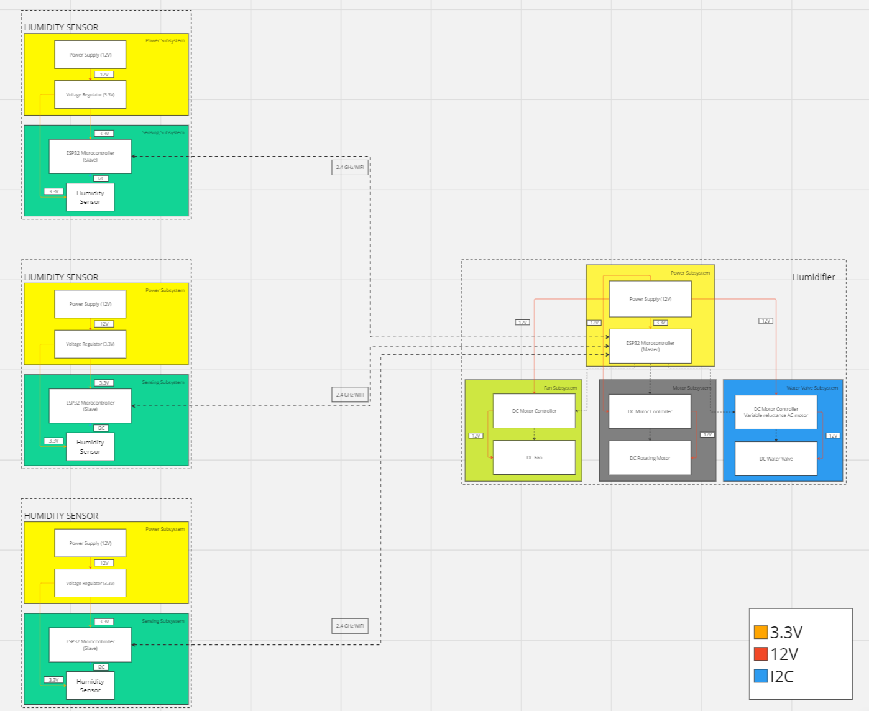

## Subsystem Overview / Requirements

### Humidifier Subsystem:

The humidifier subsystem controls the humidity output of the humidifier. This subsystem consists of a power subsystem that converts 110V AC to a 12V DC power. The 12V DC is sent through a voltage regulator. The output is a maintained 3.3V. This 3.3V is used to power the ESP32 microcontroller. The ESP32 microcontroller is the main microcontroller of the entire system. It communicates with the ESP32 microcontroller in the humidity sensor subsystems. In this relationship, the humidifier subsystem’s ESP32 is the master, and the humidity sensor subsystem’s ESP32s are the slaves. Based on the incoming data, the ESP32 will determine whether to turn on the humidifier’s fan or not. The motor uses 12V, from the power supply. When the humidifier needs more water, the ESP32 will send a signal to the water valve’s motor control system to turn on the water valve to wet the filter for X-seconds. The system knows to not add more water when the water level sensor detects liquid at the “max fill” line.

### Humidity Sensor Subsystem:

The humidity sensor subsystem detects humidity before relaying it back to the humidifier’s ESP32 microcontroller. The subsystem received power from a 110V AC to 12V DC power supply. The 12V power supply is input in a barrel jack on the PCB. The 12V is sent through a voltage regulator that maintains a 3.3V output. This 3.3V is used to power the ESP32 chip in the humidity sensor subsystem as well as the SHT45 humidity sensor. The ESP32 controls the SHT45 chip. The ESP32 in each humidity sensor subsystem serves as the master and the SHT45 is the slave. The ESP32 receives data from the SHT45 via I2C. After receiving the data, the ESP32 in the humidity sensor subsystem sends the humidity sensor’s data to the ESP32 in the humidifier subsystem. In this scenario, the ESP32 in the humidity sensor subsystem is the slave, while the ESP32 in the humidifier subsystem is the master.

### Subsystem Requirements

#### Humidifier Subsystem

1. Circuit must be powered by a 12V input source, which is then regulated at 3.3V and 6.6V for respective components.
2. ESP32 board on board must successfully receive wireless communication signals from remote ESP32 microcontrollers (humidity data)
3. ESP32 should open DC water valve when water level sensor suggests humidifier filter needs irrigation.
4. ESP32 should close DC water valve when water level sensor suggests water level is at maximum.
5. ESP32 should turn on humidifier when room humidity levels fall under a predetermined humidity percentage.
6. ESP32 should turn off humidifier when room humidity levels are above a predetermined humidity percentage.

#### Humidity Sensor Subsystem

1. Circuit must be powered by a 12V input source, which is then regulated at 3.3V and 6.6V for respective components.
2. ESP32 board should be able to communicate with SHT45 humidity sensor with I2C.
3. ESP32 board should be able to communicate with ESP32 in humidifier, relaying the SHT45’s data to it.

### Tolerance Analysis / Potential Error

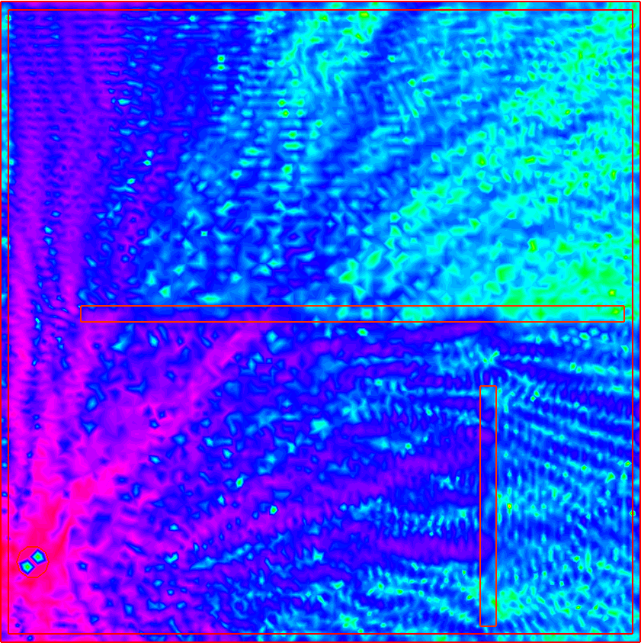 A significant aspect of our design that could pose a major risk to our project is the strength in the Wi-Fi signals being used to communicate between the sensors. Our project majorly depends on multiple microcontrollers in multiple sensors across many different areas in a room using Wi-Fi to connect to the central microcontroller. If any of these signals were interrupted, it would cause an impactful change in the way our system functions. Our completion of the project would be deemed nearly impossible without a proper wireless communication protocol, whether it be Bluetooth or Wi-Fi. For example, Wi-Fi is essentially a EM wave that operates through the medium of air containing the data we need, and can be more accurately defined using sets of Maxwell’s equations, most notably the Helmholtz equation that gives us the equation **E∇^(2) + E(k^2)/(n^2)= 0**, which are the electric fields mapped based on the angular wavenumber k and the material index n (Hecht). Below is a sample model taken from a reference site, Freefem, that will model what the signals will look like at a certain point in the area.

*Figure 1 - Signal Strength Diagram (Hecht)*

In *figure 1*, it shows a point where the electromagnetic signal is being read and the relative strength of it compared to the waves across the rest of the room. This will be how our sensors operate, with the signals being the strongest at receiving/interacting ends and having the most possible interference in between transmissions. To mitigate this issue, we will test if signals are possible to fully transmit all necessary data given multiple sensor points. If information is not fully available because of the strength or interference of other signals, we will act to measure where exactly the field is weak and create optimal positions for our sensors to generate the most effective waves. Another solution to this problem could be examining the materials that have interference potential such as metal or concrete, and either removing or replacing those materials in highly affected areas.

The accuracy of the humidity and temperature sensor also matters. According to the U.S. Environmental Protection Agency, indoor humidity should be kept between 30% and 50%. This is an adequate amount of humidity for healthy bodily function and prevents dust and other allergy causing substances from becoming easily airborne. According to Sensirion AG’s documentation in *figure 2*, the SHT45 sensor has a predicted typical error of 1% humidity between 20% and 70% humidity. The maximum error is 2% in this range. There is potential room for error when humidity increases to a point greater than 70% humidity or less than 20% humidity. We mitigate these errors because we do not believe this will happen. Furthermore, if it happens, it will not interfere with the functionality of our humidifier system. The humidifier will always be off above 50% humidity. Therefore, there is no need to worry about readings above 70%. Similarly, when the humidity falls below 20%, the humidifier will always be on. In a similar case, there is no need to worry about humidity values and the higher potential for a reading error below 20% humidity.

Aside from the accuracy of the readings, the data communication between the humidity sensor and the ESP32 board also is quite important. If the trace on the PCB is a distance that is too long, it might cause a signal mismatch by the receiver. Furthermore, the bus speed also matters. There are multiple modes for I2C, with the standard mode transferring data at 100Kbits/s, fast mode transferring data at 400Kbits/s, and high-speed mode at 3.4Mbits/s. While faster modes can communicate with a slow-mode device, a slow mode device is unable to communicate with a fast-mode device. As a result, the SHT45 and the ESP32 microcontroller must use handshake to communicate without data loss. Aside from that, the PCB traces must be kept at a minimum length, so that data does not get slowed down during transmission.

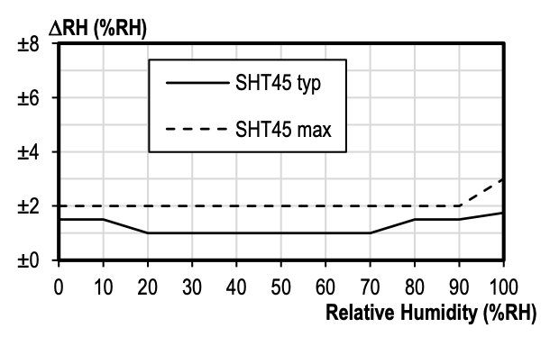

*Figure 2 – SHT45 Humidity Accuracy Rating*

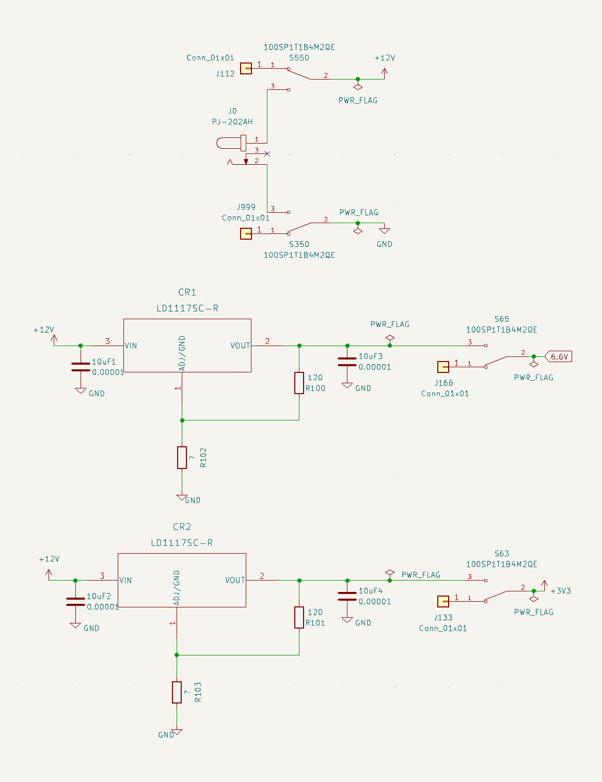In the KiCAD schematic below (*figure 3*), we see the barrel jack connection and the voltage regulator set-up that we will be using. There are physical switches in the barrel jack port and the voltage regulators for a secondary backup power source. This is done due to the potential error case of a static discharge from an error handling the PCB. The LD1117SC-R adjustable voltage regulators are sensitive to static discharge. With a switch that can change the PCB power to a DC power supply, this addresses the issue in the case of a potential static discharge frying the electronic component.

*Figure 3 – KiCad Voltage Regulator Design*

# Ethics and Safety

For our initial examination of ethics, we were able to justify our project using the IEEE code of ethics. As students and soon-to-be workers, we know that whatever we do will have an impact on the world, primarily through the products and services we work on. Therefore, we must make sure to set some ethical guidelines that match with the code.

1. To uphold the highest standards of integrity, responsible behavior, and ethical conduct in professional activities. (IEEE, 2020)
   1. We will keep an open-minded state to each other's opinions. Utilizing everyone’s opinions, we will try to find the most ideal solution to our problems.
   2. We will keep the integrity of our research to the highest degree. All data collected will be the truthful original and will not be “tuned” in any way.
   3. We will keep the safety of our members and those working around us to the utmost highest standard.
   4. We will adhere to the rules and regulations of the University of Illinois and ECE445’s lab conduct rules.
   5. Constructive advice and criticisms will be accepted, and any forms of bribery will not be tolerated.
2. To treat all persons fairly and with respect, to not engage in harassment or discrimination, and to avoid injuring others. (IEEE, 2020)
   1. We will treat all members within and outside our group with respect on physical and non-physical standpoints.
   2. Sexual harassment is not tolerated and will be reported to appropriate parties.
3. To strive to ensure this code is upheld by colleagues and co-workers. (IEEE, 2020)
   1. We will strive to uphold this code of conduct provided from IEEE and in our team contract. Any behavior outside the rules will be reported to the correct authorities.
4. To seek, accept, and offer honest criticism of technical work, to acknowledge and correct errors, to be honest and realistic in stating claims or estimates based on available data … (IEEE, 2020)
   1. A central ethical concern includes directly impacting humans as a first resort without being able to test otherwise. For example, for most scientific products, humans are the final stage of a trial in a product because all previous stages have been cleared or given approval through uses of inanimate objects or lab animals. Our problem is generally a comfort-based one, and so the general ethical concern would be the first stage exposure to humans since there would not be a test trial. If our main issue is comfort, we will never know how it feels until actual humans have tested it. Therefore, as one of the IEEE Code of Ethics indicates, we will seek and accept any technical criticisms from TA, instructors, and machine shop, be realistic and responsible to revise the problem until we reach agreement. On top of that we will measure the humidity carefully and regulate with the correct amounts of moisture, making sure that we only deviate from the average quantity only once we have received indication that it is comfortable.
5. A safety concern is the issue of potential bacteria and mold. Our automatic humidifier should get rid of this, but this issue could severely impact the humidifier if there turns out to be traces of something contagious that can be widespread with the device. The dangers of something airborne that could get into your lungs would be catastrophic if not regulated correctly.
6. Another possible safety issue could be the moving parts of a fan that could injure you if you try to touch the mechanical components. The fan’s motor will likely be insulated from external touch, but there is always a chance that something breaks and another chance that the moving part accidentally meets someone, leading to a higher chance of injury.
7. A common matter that arises as well is if there is a connected cable that meets water. Our humidifier will likely be powered through a wired connection, and any water that comes into contact either from the humidifier or an external water source will damage the system, or even worse, cause physical harm to someone. This safety issue would need to be fixed through epoxy or some type of non-porous material insulating the device and its connections.
8. Dangerous chemicals are a final hazard that could be caused intentionally or by accident. Chemicals could be an issue if put inside the supply which normally contains water. If a dangerous fluid was put in the supply on purpose, then the humidifier might act as normal, sensing the humidity levels and then dispersing a life-threatening liquid instead of water. This would cause great harm and even possibly death if misused, so it is of utmost importance that the person using the device is careful and is sensible. Otherwise, the designers are not subject to responsibility and take no claim in the misuse of the product, which in that case, the user should refer to the instructions provided.

# References

1. Hecht, F. (n.d.). WiFi Propagation . WIFI propagation. <https://doc.freefem.org/tutorials/wifiPropagation.html>
2. Marwell, M. (2018, August 9). Issues with the I2C (inter-ic) bus and how to solve them. *DigiKey*. <https://www.digikey.com/en/articles/issues-with-the-i2c-bus-and-how-to-solve-them>
3. Sensirion. (2023). SHT4x 4th Generation, High-Accuracy, Ultra-Low-Power, 16-bit Relative Humidity and Temperature Sensor. In *Sensirion Official Documentation* (Issue 6). Sensirion.
4. United States Environmental Protection Agency. (2014, August 28). *Care for your air: A guide to indoor air quality*. US EPA. <https://www.epa.gov/indoor-air-quality-iaq/care-your-air-guide-indoor-air-quality>
5. Espressif. (2023). *ESP32-S3-WROOM-1 ESP32-S3-WROOM-1U Datasheet*. Espressif. <https://www.espressif.com/sites/default/files/documentation/esp32-s3-wroom-1_wroom-1u_datasheet_en.pdf>
6. Metageek. (2024). *Wi-Fi and non wi-fi interference*. MetaGeek. <https://www.metageek.com/training/resources/wifi-and-non-wifi-interference/>
7. Arundel, A. V., Sterling, E. M., Biggin, J. H., & Sterling, T. D. (1986). Indirect health effects of relative humidity in indoor environments. *Environmental Health Perspectives*, *65*, 351–361. <https://doi.org/10.1289/ehp.8665351>
8. Perrone, V., Veronesi, C., Giacomini, E., Citraro, R., Dell’Orco, S., Lena, F., Paciello, A., Resta, A. M., Nica, M., Ritrovato, D., & Degli Esposti, L. (2022). The epidemiology, treatment patterns and economic burden of different phenotypes of multiple sclerosis in Italy: Relapsing-Remitting multiple sclerosis and secondary progressive multiple sclerosis. *Clinical Epidemiology*, *14*, 1327–1337. <https://doi.org/10.2147/CLEP.S376005>
9. IEEE. (2020). *IEEE code of ethics*. IEEE Code of Ethics. <https://www.ieee.org/about/corporate/governance/p7-8.html>